### Mr. Torus Snowman - Happy Snow Day!

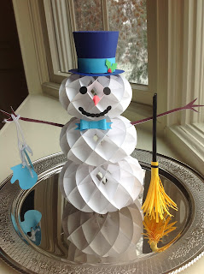

Mr. Torus Snowman

I created a snowman today...what a wonderful thing to do on a snow day from school. I didn't even have to put my coat on to make my snowman!  
  
The trees are glistening outside from the snow and ice...a winter wonderland. As I was making this snowman, I heard a crack outside and down came a huge branch from a pine tree. Luckily the tree was nowhere near my house and no one was underneath the tree because certainly the tree branch would have caused some damage because of its size. It makes me thankful to be home doing my crafts.Cut 24 of each torus piece (half-moon circles). They are graduated in size...use the smallest torus for the top and so on until all three are made. The directions for making the torus are in a previous post. <http://papercraftetc.blogspot.com/2013/10/a-honeycomb-pumpkin-decoration-for-fall.html>I cut the arms twice and glued them back-to-back because the paper I was using was white on the back and also, I wanted the arms to be sturdier. The carrot nose is rolled into a cone like the witch's/wizard's hat from a previous post. Add the eyes, mouth and nose. The directions for the bow tie are at the end of a previous post <http://papercraftetc.blogspot.com/2013/11/holly-wreath-torus.html>

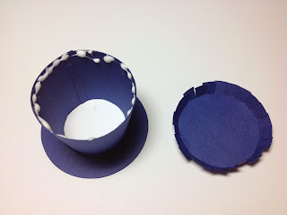

Glue the hat piece into circle and attach the brim to the outside of the hat piece. Bend the top of the hat as shown

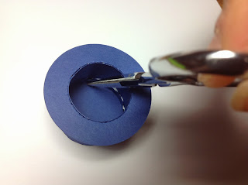

I used a pair of scissors to make sure that the glue adhered correctly to the top of the hat.

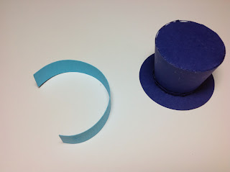

Attach the hat band and the holly to the hat.

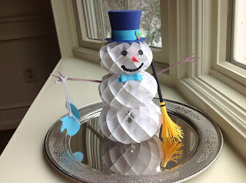

Happy Snow Day!